Create an S3 bucket, configure the bucket for website hosting, and secure it using IAM policies.
S3 bucket in the AWS Management Console
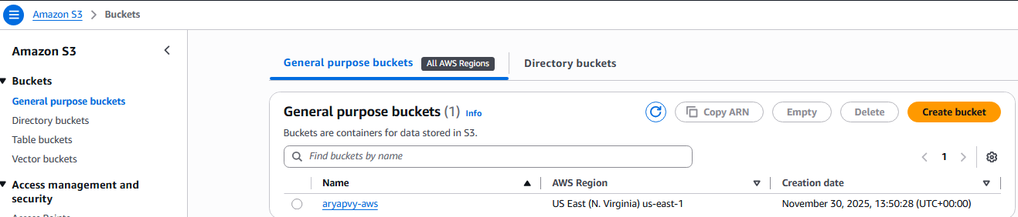
See that the bucket allows public access for hosting.
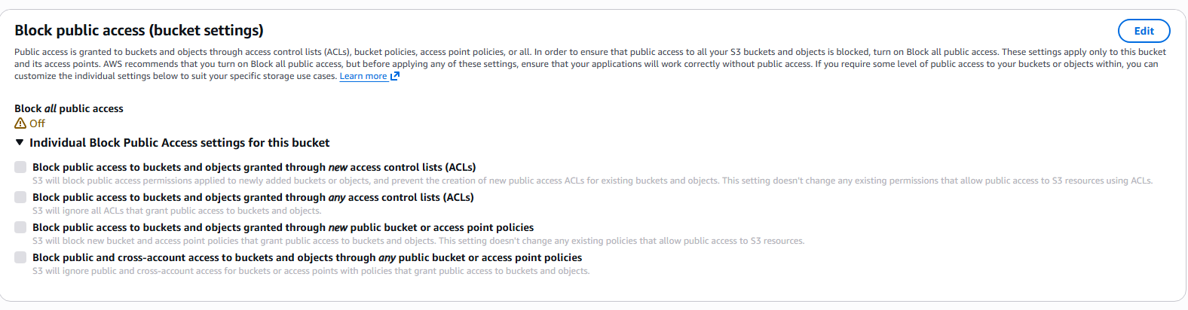
Enter the following bucket policy replacing your-website with the name of your bucket

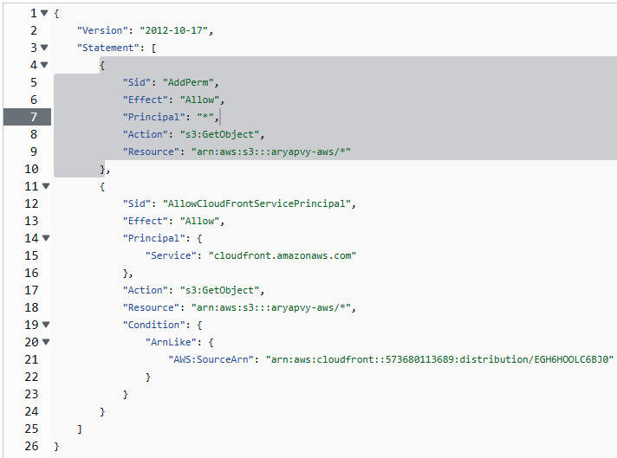
Upload the website files to your bucket and speed up content delivery using AWS’s content distribution network service, CloudFront.
Uploaded starter code in the bucket
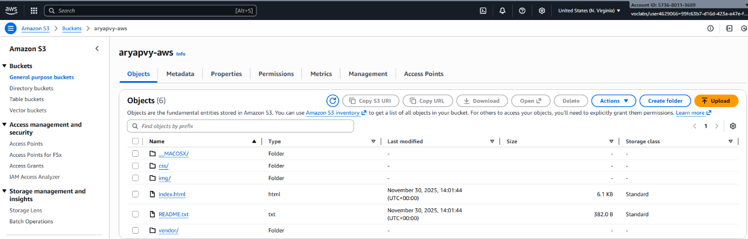
Enable the Static website hosting, and provide the default home page and error page for your website.
For both “Index document” and “Error document”, enter “index.html”

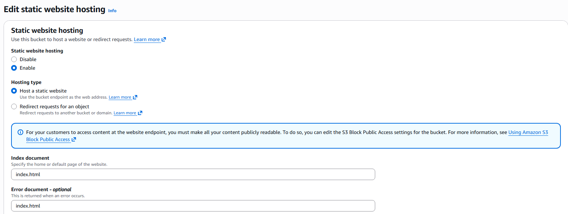

Create a distribution, Static website hosting endpoint. Do not enable origin shield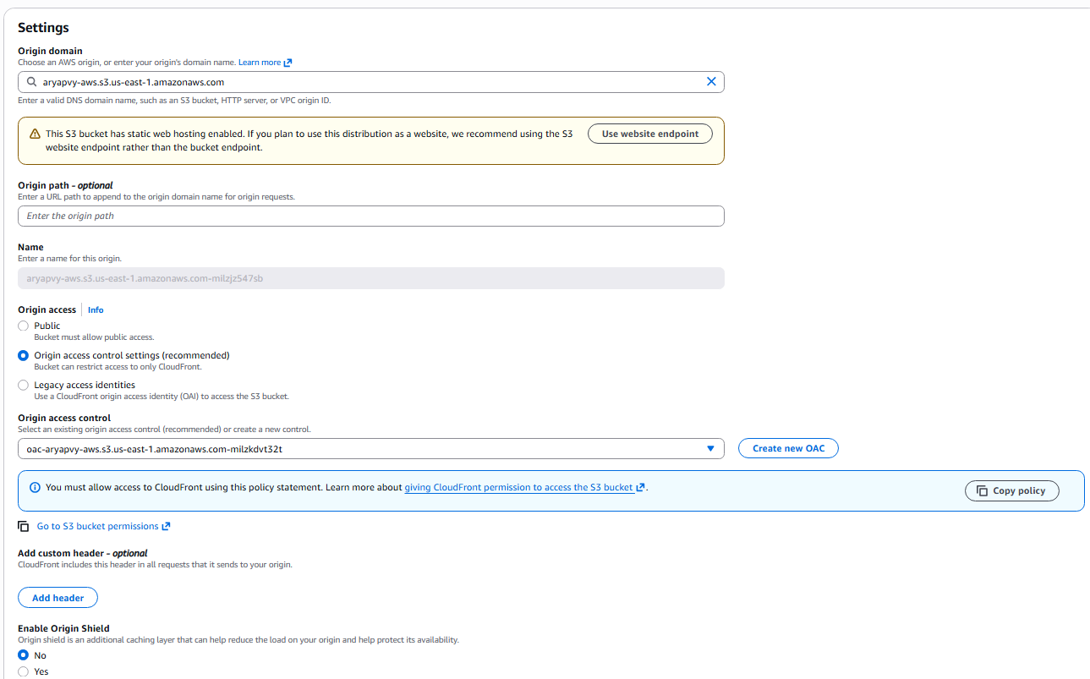

Default cache behaviour and cache key and origin requests
